CS 480
Updated Design Document

Document Control

Document Information
© | Information
Document Owner | Team J.A.K.E.
Issue Date | 11/21/2025
Last Saved Date | 11/24/2025
File Name | Upd Design Document – Team J.A.K.E.

Document History
Version | Issue Date | Changes
[1.0] | 10/23/2025 | Completed the Design Document
[2.0] | 11/24/2025 | Updated the Design Document

Table of Contents

1. Introduction 5
1.1. Purpose 5
1.2. Scope of the project 5
1.3. Glossary 5
1.4. References 6
2. System Design 7
2.1. System Architecture 7
2.2. Component: Locations 7
2.2.1. Activity Diagrams 8
2.2.1.1. Manage Locations Add 8
2.2.1.2. Manage Locations Edit 9
2.2.1.3. Manage Locations Delete 10
2.2.1.4. Select Locations 11
2.2.1.5. Search Locations 12
2.2.2. Input Data 12
2.2.2.1. Manage Locations (Add, Edit, Delete) 12
2.2.2.2. Select Locations 12
2.2.2.3. Search Locations 13
2.2.3. Output Data 13
2.2.3.1. Manage Locations (Add, Edit, Delete) 13
2.2.3.2. Select Locations 13
2.2.3.3. Search Locations 13
2.2.4. User Interfaces 14
2.2.4.1. Manage Locations 14
2.2.4.2. Select Locations 14
2.2.4.3. Search Locations 15
2.3. Component: Dashboard 16
2.3.1. Activity Diagrams 16
2.3.1.1. Display Weather Map 16
2.3.1.2. Display Weekly Weather Data 17
2.3.2. Input Data 18
2.3.2.1. Display Weather Map 18
2.3.2.2 Display Weekly Weather Data 18
2.3.3. Output Data 18
2.3.3.1. Display Weather Map 18
2.3.3.2 Display Weekly Weather Data 18
2.3.4. User Interfaces 18
2.3.4.1. Display Weather Map 18
2.3.4.2. Display Weekly Weather Data 19
2.4. Component: User 20
2.4.1. Activity Diagrams 20
2.4.1.1. Sign Up 20
2.4.1.2. Log In 21
2.4.1.3 Forgot Password 22
2.4.2. Input Data 22
2.4.2.1. Sign Up 22
2.4.2.2. Log In 23
2.4.2.3. Forgot Password 23
2.4.3. Output Data 23
2.4.3.1. Sign Up 23
2.4.3.2. Log In 23
2.4.3.3. Forgot Password 23
2.4.4. User Interfaces 24
2.4.4.1. Sign Up 24
2.4.4.2. Log In 24
2.4.4.3. Forgot Password 25
2.5. Component: Controller 26
2.5.1. Activity Diagrams 26
2.5.1.1. Controller Input 26
2.5.1.2. Controller Output 27
2.5.2. Input Data 27
2.5.2.1. Controller Input 27
2.5.2.2. Controller Output 27
2.5.3. Output Data 28
2.5.3.1. Controller Input 28
2.5.3.2. Controller Output 28
2.5.4. User Interfaces 28
2.5.4.1. Controller Input 28
2.5.4.2. Controller Output 28
2.6. Component: User Model 29
2.6.1. Activity Diagram 29
2.6.2. Input Data 29
2.6.3. Output Data 29
2.6.4. User Interfaces 29
2.7. Component: Favorite Locations Model 30
2.7.1. Activity Diagram 30
2.7.2. Input Data 30
2.7.3. Output Data 30
2.7.4. User Interfaces 30
3. Data Design 31
3.1. ERD 31
3.2. Data Dictionary 31
3.3. API Data 32
4. User Interface Navigation Flow 32
5. Requirements Traceability Matrix 33
6. Updated Requirements With Text 35
6.1 Log In 35
6.1.1 Functional 35
6.1.2. Non-Functional 35
6.2 Display Weather Map 36
6.2.1. Functional 36
6.2.2. Non-Functional 36
6.3 Select Location 36
6.3.1. Functional 36
6.4 Display Weekly Weather Data 37
6.4.1. Functional 37
6.5 Search Location 37
6.5.1. Functional 37
6.5.2. Non-Functional 37
6.6 Manage Locations 38
6.6.1. Functional 38
6.6.2. Non-Functional 38
6.7 Forgot Password 39
6.7.1. Functional 39
6.7.2. Non-Functional 39
6.8 Sign Up 40
6.8.1. Functional 40
6.8.2. Non-Functional 40

1. Introduction

1.1. Purpose
The purpose of the design document is to introduce the overall design structure of the J.A.K.E. Weather application. The system design section will detail the overall system architecture using a narrative description and a component diagram. Additionally, each component diagram will include a comprehensive description, detailed activity diagrams, tables to explain the input and output data, and user interfaces used within the component. The next section is data design, which will detail our ERD for the system’s persistent data, a data dictionary table for describing each data element, and an API data table for describing any data received from API calls. The next section is user interface navigation flow and details the interface flow for all interfaces in the system. The last section is our requirements traceability matrix, used to map each design component to the appropriate requirements and use cases.

1.2. Scope of the project
The scope of this project is to successfully design, develop, and deliver a fully functional, authenticated, weather application. The application will serve as a user-centric interface for retrieving, displaying, and managing real-time weather information using external data providers.

In Scope | Not in Scope
Users can save up to 10 favourite locations | Users can save more than 10 favourite locations
Users can switch between favourite locations to see the weather data | Weather data for previous days
Users can view their immediate location | Weather data available for minutes, seconds, and hours
Secure user authentication | Adding an ‘AI’ weather assistant
Users can search for different locations using the weather map | Historical or long-term weather data
Radar display for users' immediate location | Guest access without authentication
Weather data daily (up to 7 days) display | Native mobile app development
Users can update their forgotten password | Notification system alerting the user
Users can switch the map style (e.g. Radar style)
Users can delete from their favorite locations
Users have navigation ability on the weather map

1.3. Glossary
- Activity Diagram – Similar to flowcharts that display the flow between actors in an activity
- Actor – A role played by a user, another system, or hardware that interacts with the system by exchanging data and signals
- API – Application Programming Interface
- API Call – Involves sending a message to a server to request a service from an API
- API Google Geolocation – Determines devices geolocation
- API Google Geocoding – Determines latitude and longitude from an address or location
- API Google Maps – Gives the ability to utilize google maps map features
- API Open Meteo Weather – Provides real-time and forecast weather data for specific locations
- API Open Weather Maps – Provides different versions of map such as precipitation and temperature
- Component Diagram – A visual representation of a systems structure showcasing its components and interactions
- Data Dictionary – Stores a collection of data elements detailing the associated table, attribute name, data type, and description
- ERD – Visual tool that used to model a database’s structure by showing relationships between entities
- J.A.K.E. – Represents the first letter of each of our names
- MVC – Model View Controller, software design pattern that separate in application into the model: data handling, the view: what a user sees, and the controller: the linkage between the model and the view
- Requirements Traceability Matrix – Project requirements in relation to design and test cases
- UCML – A set of symbols for performance testing models or using the UML to model the users and interaction within a system
- UML – A standardized visual language used for software engineering, business modeling, and other non-software systems
- User Interface – The space where interaction between the users and the system occurs
- WMO Weather Code – Refers to the standardized, internationally recognized numerical weather code from World Meteorological Organization (WMO)

1.4. References
- API Open Meteo Weather. This API will be the main source of our weather data, offering weekly weather for specified locations.
https://open-meteo.com/en/docs/historical-weather-api

- API Google Geolocation. We will use this API to get the user’s current location.
https://developers.google.com/maps/documentation/geolocation/overview

- API Google Maps. This API will be a part of our Weather Map feature, ensuring that we have a clean and responsive map.
https://mapsplatform.google.com/lp/maps-apis/

- API Google Geocoding. This API will be a part of the Manage Locations feature, where the newly added location will be converted to latitude and longitude. We need this information for the Open Meteo Weather API.
https://developers.google.com/maps/documentation/geocoding/overview

- API Open Weather Maps. We will use this API to display a radar style weather map of the user’s current or specified location.
https://openweathermap.org/api/weathermaps

- WMO Code Table 4677. This Website give information of weather codes which provided from Open-Meteo Weather API. Weather codes will determine which weather icons we are using for the weekly weather data.
https://www.nodc.noaa.gov/archive/arc0021/0002199/1.1/data/0-data/HTML/WMO-CODE/WMO4677.HTM

2. System Design

2.1. System Architecture
Our overall system architecture will follow the MVC (Model View Controller) design pattern. This pattern separates the application into three interconnected parts, each handling a specific development aspect: the Model will handle all database definitions, the View will handle all user interfaces, and the Controller will handle all logical actions. The decision to use the MVC design pattern was primarily influenced on the focus of promoting a modular, maintainable, and scalable application.
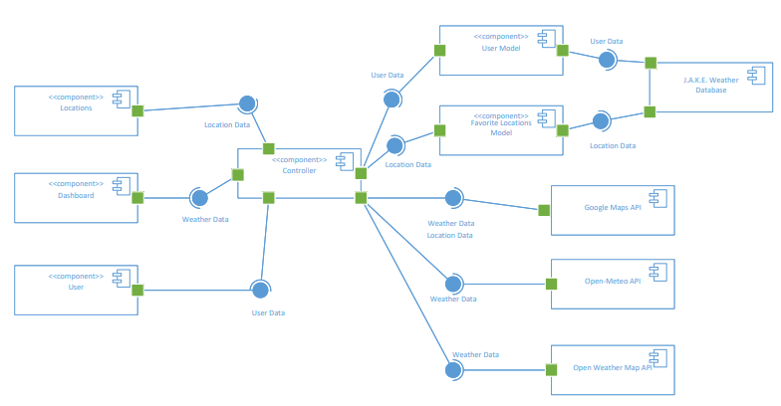

2.2. Component: Locations
The Locations Component handles all the functionality dealing with locations within our weather application. There will be five activity diagrams categorized in the Locations Component: three for Manage Locations for adding/editing/deleting favorite locations, one for Select Locations for selecting between favorite locations, and one for Search Locations for searching locations on the Weather Map. Interactions detailed by the Manage Locations and Select Locations activity diagrams will be instructed by the Controller Component to interact with the Favorite Locations Model Component to access the J.A.K.E. Weather Database. The interaction detailed by the Search Location activity diagram will be instructed by the Controller Component to interact with the Google Maps API.

2.2.1. Activity Diagrams

2.2.1.1. Manage Locations Add
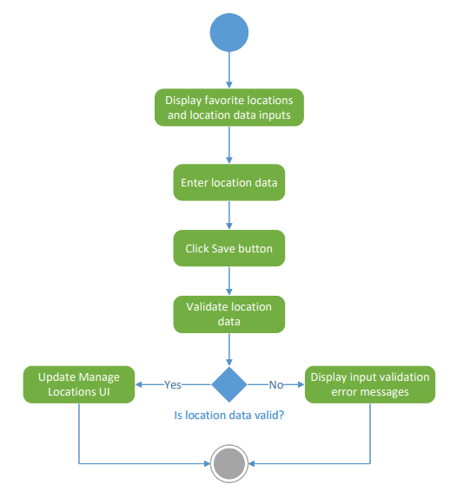

2.2.1.2. Manage Locations Edit
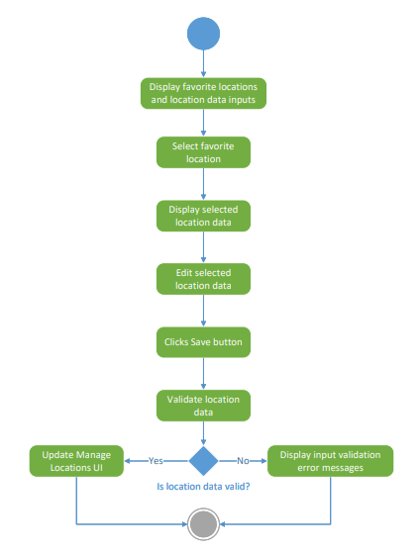

2.2.1.3. Manage Locations Delete
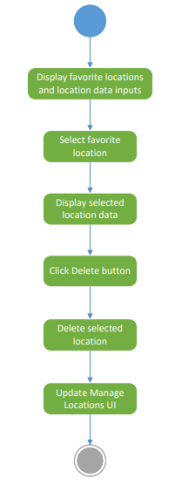

2.2.1.4. Select Locations
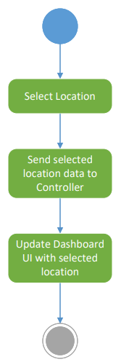

2.2.1.5. Search Locations
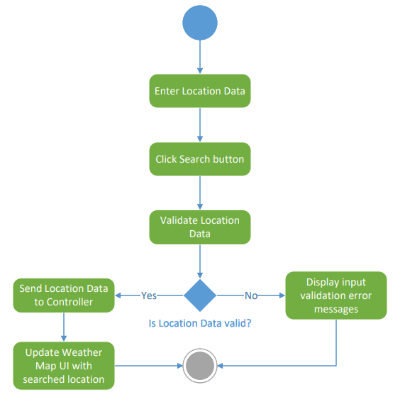

2.2.2. Input Data

2.2.2.1. Manage Locations (Add, Edit, Delete)
Data Item | Origin
City | User
State | User
Country | User
Zip | User

2.2.2.2. Select Locations
Data Item | Origin
Selected Location | User

2.2.2.3. Search Locations
Data Item | Origin
Searched Location | User

2.2.3. Output Data

2.2.3.1. Manage Locations (Add, Edit, Delete)
Data Item | Destination
City | Locations Component & J.A.K.E. Weather Database
State | Locations Component & J.A.K.E. Weather Database
Country | Locations Component & J.A.K.E. Weather Database
Zip | Locations Component & J.A.K.E. Weather Database

2.2.3.2. Select Locations
Data Item | Destination
Selected Location | Locations Component

2.2.3.3. Search Locations
Data Item | Destination
Searched Location | Location Component

2.2.4. User Interfaces

2.2.4.1. Manage Locations
Manage Locations within the Locations Component uses the Manage Locations UI to allow users to manage their favorite locations. The user is able to add a new favorite location, edit a pre-existing favorite location, and delete a pre-existing favorite location. Clicking the Add/Remove button under Manage Locations on the left side of the Dashboard UI will open the Manage Locations UI. Once the user has navigated to the Manage Locations UI, clicking the X button on the top right will close it. The initial Manage Locations UI will have the Location Info inputs blank, allowing the user to add a new favorite location. Clicking one of the Added Locations on the left side will populate the Location Info inputs accordingly. After users have added to/edited the Location Info inputs, clicking the Save button will complete the action. Clicking the Delete button will delete the current location that is being populated in the Location Info.
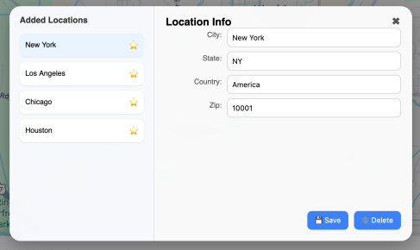
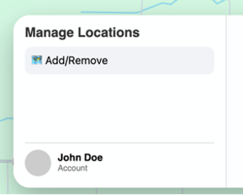

2.2.4.2. Select Locations
Select Locations within the Locations Component uses the Dashboard UI to allow users to select a location from their Favorite Locations list. The Favorite Locations list is located on the right side of the Dashboard UI and allows users to scroll through all of their favorite locations. Clicking on a favorite location will update the entire Dashboard UI accordingly, this is to allows users to view weather data for each of their favorite locations.
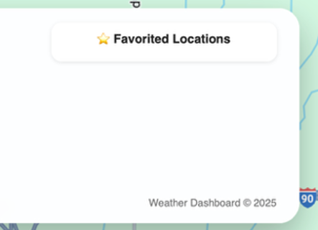

2.2.4.3. Search Locations
Search Locations within the Locations Component uses the Weather Map UI to allow users to search for a location using the Search Location input in the top right corner of the Weather Map UI. The Search Location input will display options most closely matching to what the user is typing. Clicking the Search button will perform the search and update the Weather Map UI accordingly upon success.
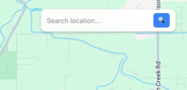

2.3. Component: Dashboard
The Dashboard Component handles all the functionality dealing with the dashboard within our weather application. There will be two activity diagrams categorized in the Dashboard Component: Display Weather Map for rendering the users’ specified location on the weather map and Display Weekly Weather Data for detailing the users’ specified location weather data. Interactions detailed by the Display Weather Map and Display Weekly Weather Data activity diagrams will be instructed by the Controller Component to interact with the Google Maps API, Open-Meteo API and Open Weather Map API.

2.3.1. Activity Diagrams

2.3.1.1. Display Weather Map
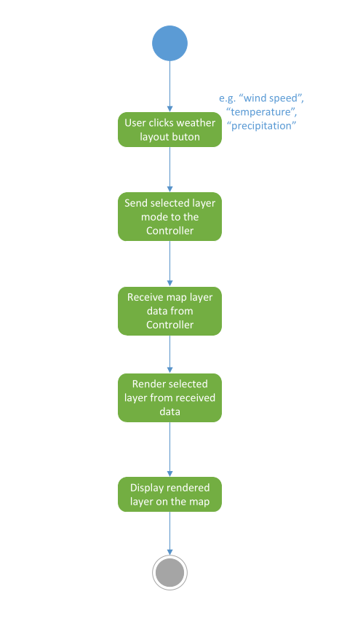

2.3.1.2. Display Weekly Weather Data
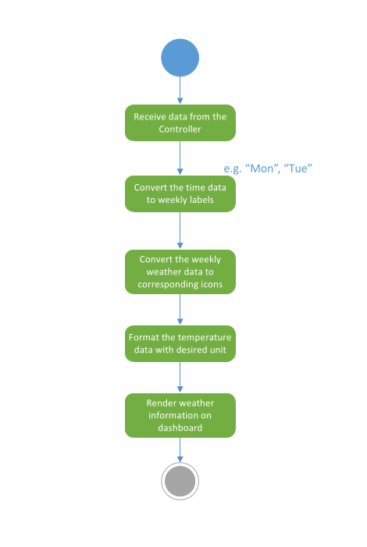

2.3.2. Input Data

2.3.2.1. Display Weather Map
Data Item | Origin
Map Layout Type | User

2.3.2.2 Display Weekly Weather Data
Data Item | Origin
Longitude | J.A.K.E. Weather Database
Latitude | J.A.K.E. Weather Database

2.3.3. Output Data

2.3.3.1. Display Weather Map
Data Item | Destination
Map Layer | Open Weather API & Dashboard Component

2.3.3.2 Display Weekly Weather Data

Data Item | Destination
Weekly Dates | Open-Meteo API & Dashboard Component
Weekly Temperatures | Open-Meteo API & Dashboard Component
Weekly Weathers Categories | Open-Meteo API & Dashboard Component

2.3.4. User Interfaces

2.3.4.1. Display Weather Map
Display Weather Map within the Dashboard Component will use the Weather Map UI to allow users to navigate on four different map types. The default map type will be Geographical and the users can switch to the other three map types (Wind Speed, Precipitation, and Temperature) by clicking on the corresponding Map Type Icon buttons. Users are also able to zoom in and out of the Weather Map UI as well as move around on the map.
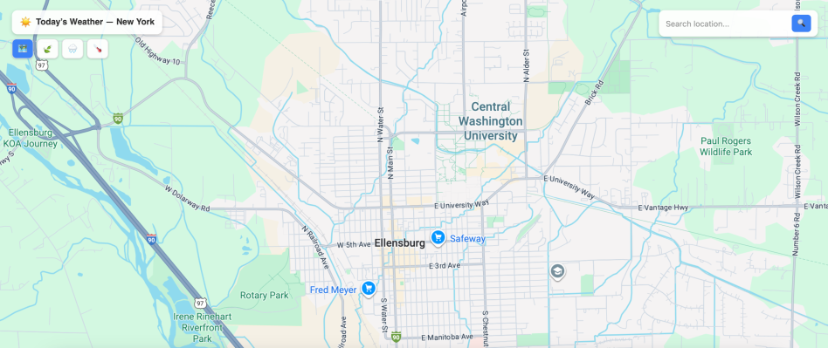

2.3.4.2. Display Weekly Weather Data
Display Weekly Weather Data within the Dashboard Component will use the Weekly Weather UI to allow users to view weekly weather data according to their specified location. The Weekly Weather UI will detail a seven day forecast where each day includes the date, temperature, and weather category.
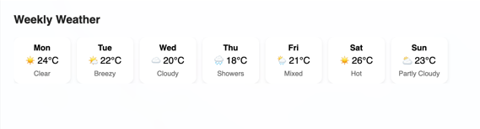

2.4. Component: User
The User Component handles all the functionality dealing with users within our weather application. There will be three activity diagrams categorized in the User Component: Sign Up for registering for an account, Log In for logging into an account, and Forgot Password for handling forgotten passwords. Interactions detailed by the Sign Up, Log In, and Forgot Password activity diagrams will be instructed by the Controller Component to interact with the User Model Component to access the J.A.K.E. Weather Database.

2.4.1. Activity Diagrams

2.4.1.1. Sign Up
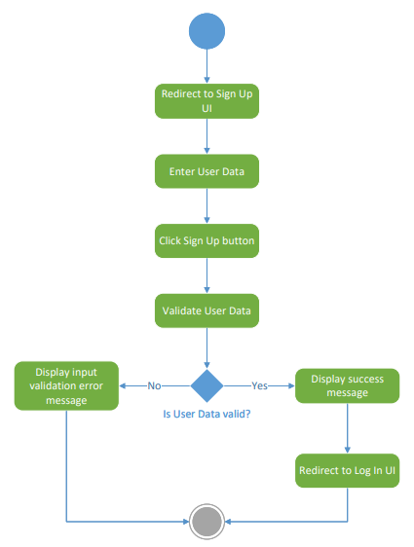

2.4.1.2. Log In
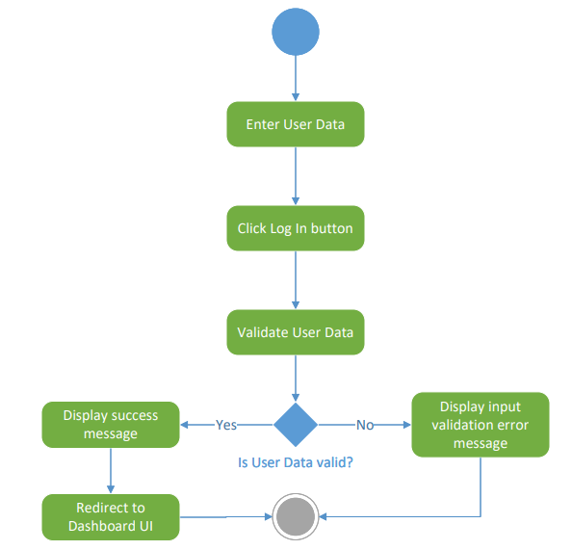

2.4.1.3 Forgot Password
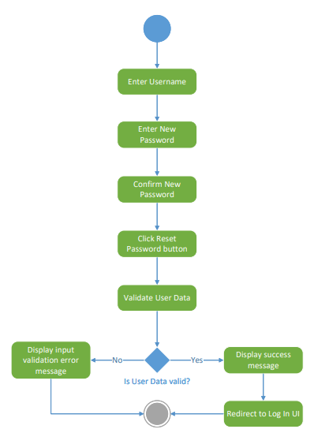

2.4.2. Input Data

2.4.2.1. Sign Up

Data Item | Origin
First Name | User
Last Name | User
Username | User
Email | User
Password | User
Country | User
State | User
Zip Code | User
City | User

2.4.2.2. Log In

Data Item | Origin
Username | User
Password | User

2.4.2.3. Forgot Password

Data Item | Origin
Username | User
New Password | User
Confirm New Password | User

2.4.3. Output Data

2.4.3.1. Sign Up

Data Item | Destination
First Name | J.A.K.E. Weather Database
Last Name | J.A.K.E. Weather Database
Username | J.A.K.E. Weather Database
Email | J.A.K.E. Weather Database
Password | J.A.K.E. Weather Database
Country | J.A.K.E. Weather Database
State | J.A.K.E. Weather Database
Zip Code | J.A.K.E. Weather Database
City | J.A.K.E. Weather Database

2.4.3.2. Log In

Data Item | Destination
Username | J.A.K.E. Weather Database
Password | J.A.K.E. Weather Database

2.4.3.3. Forgot Password

Data Item | Destination
Username | J.A.K.E. Weather Database
New Password | J.A.K.E. Weather Database
Confirm New Password | J.A.K.E. Weather Database

2.4.4. User Interfaces

2.4.4.1. Sign Up
Sign Up within the User Component will use the Sign Up UI to allow users to register for an account within our weather application. The user must enter the valid specified user information before clicking the Sign Up button. If the entered information is invalid or an input is left blank, an appropriate error message will display to the Sign Up UI. Clicking the Eye buttons on the Password and Confirm Password inputs will toggle the input text between hidden and non-hidden. Clicking the Sign Up button will redirect the user to the Log In UI only upon successful registration.
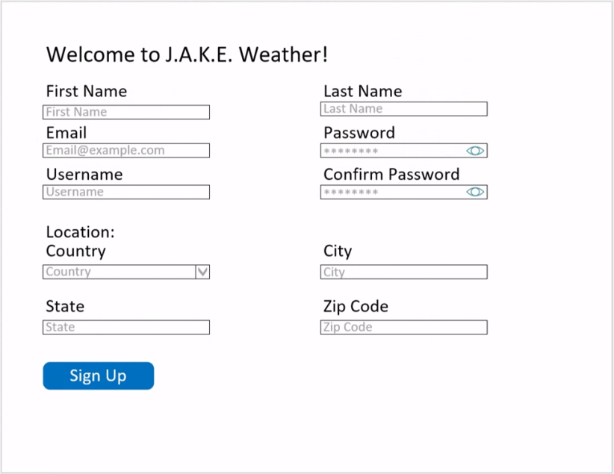

2.4.4.2. Log In
Log In within the User Component will use the Log In UI to allow users to log into their account within our weather application. The user must enter the valid specified user information before clicking the Log In button. If the entered information is invalid or an input is left blank, an appropriate error message will display to the Log In UI. Clicking the Eye button on the Password input will toggle the input text between hidden and non-hidden. Clicking the Forgot Password button will redirect the user to the Forgot Password UI. Clicking the Sign Up button will redirect the user to the Sign Up UI. Clicking the Log In button will redirect the user to the Dashboard Component only upon successful log in.
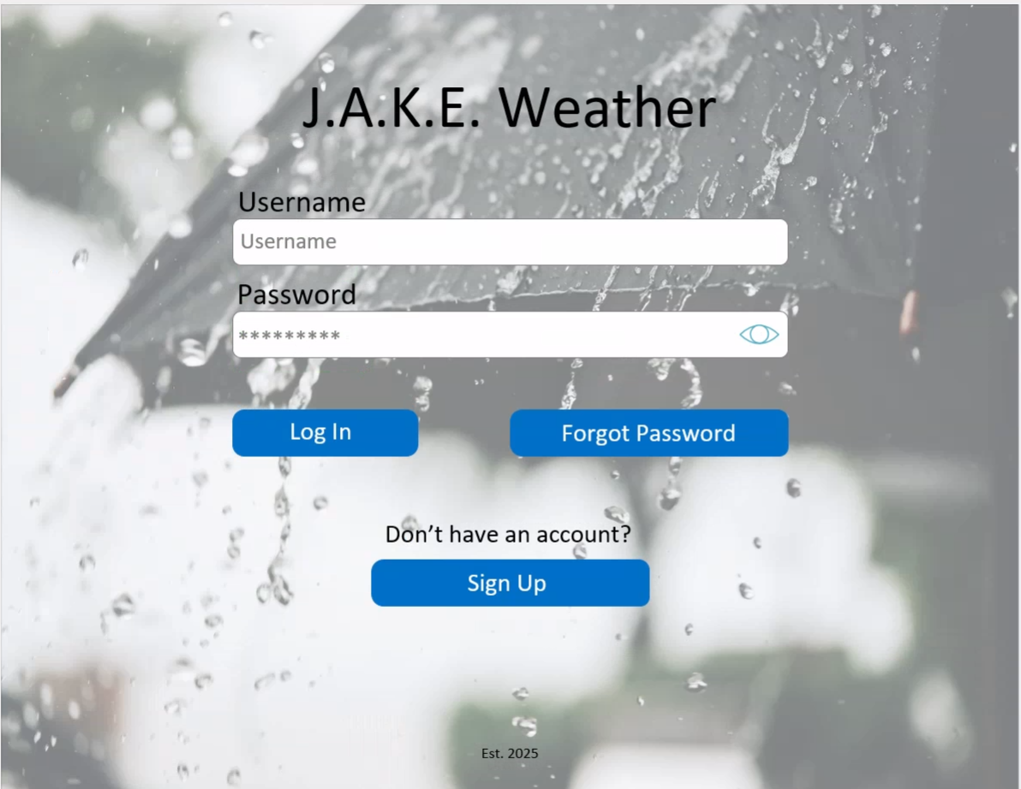

2.4.4.3. Forgot Password
Forgot Password within the User Component will use the Forgot Password UI to allow users to reset their forgotten password within our weather application. The user must enter the valid specified user information before clicking the Reset Password button. If the entered information is invalid or an input is left blank, an appropriate error message will display to the Forgot Password UI. Clicking the Eye buttons on the New Password and Confirm New Password inputs will toggle the input text between hidden and non-hidden. Clicking the Reset Password button will redirect the user to the Log In UI upon successful reset of their password.
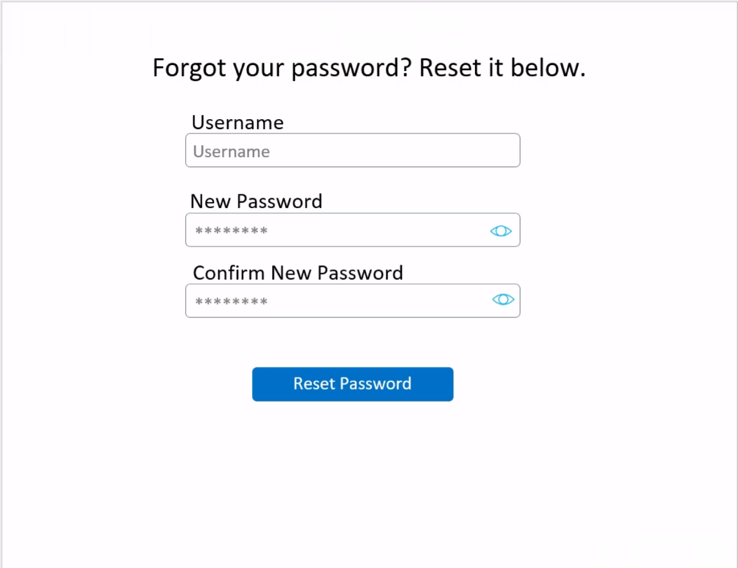

2.5. Component: Controller
The Controller Component handles all the logic within our weather application. There will be two activity diagrams categorized in the Controller Component: Controller Input and Controller Output. The Controller Input activity diagram will detail the logical flow of how the Controller Component controls data that is sent from the Views to the appropriate Models and external APIs. The Controller Output activity diagram will detail the logical flow of how the Controller Component controls data that is sent from the Models and external APIs back to the appropriate Views.

2.5.1. Activity Diagrams

2.5.1.1. Controller Input
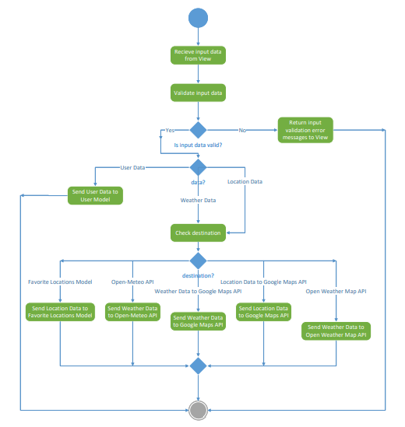

2.5.1.2. Controller Output
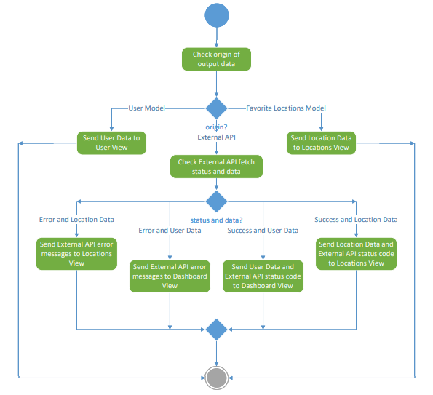

2.5.2. Input Data

2.5.2.1. Controller Input

Data Item | Origin
User Data | User
Location Data | User
Weather Data | Google Maps API, Open-Meteo API, Open Weather Map API

2.5.2.2. Controller Output
N/A

2.5.3. Output Data

2.5.3.1. Controller Input

Data Item | Destination
User Data | User
Location Data | User
Weather Data | Google Maps API, Open-Meteo API, Open Weather Map API

2.5.3.2. Controller Output
N/A

2.5.4. User Interfaces

2.5.4.1. Controller Input
N/A

2.5.4.2. Controller Output
N/A

2.6. Component: User Model

2.6.1. Activity Diagram
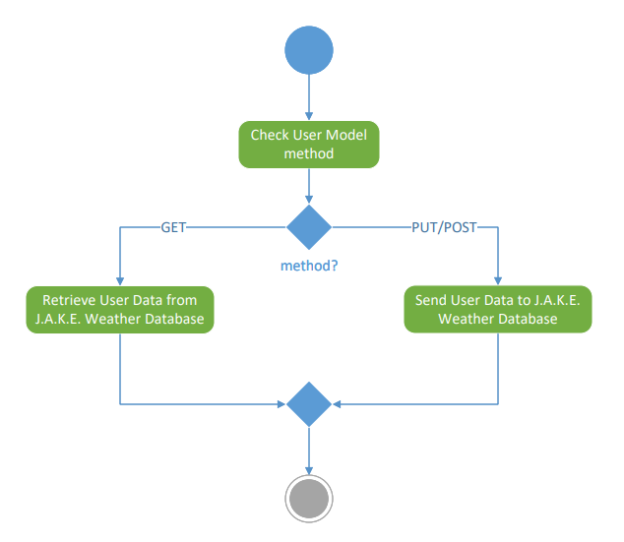

2.6.2. Input Data
Data Item | Origin
User Data | User

2.6.3. Output Data
Data Item | Destination
User Data | User Component
User Data | J.A.K.E. Weather Database

2.6.4. User Interfaces
N/A

2.7. Component: Favorite Locations Model

2.7.1. Activity Diagram
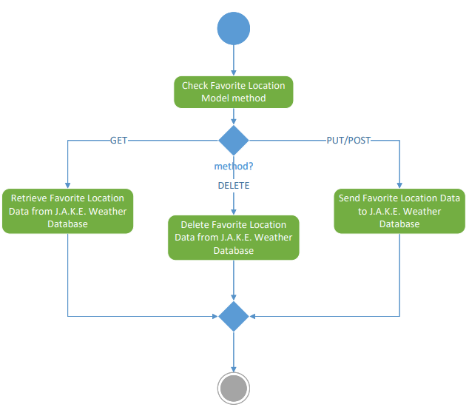

2.7.2. Input Data
Data Item | Origin
Location Data | User

2.7.3. Output Data
Data Item | Destination
Location Data | Locations Component
Location Data | J.A.K.E. Weather Database

2.7.4. User Interfaces
N/A

3. Data Design

3.1. ERD
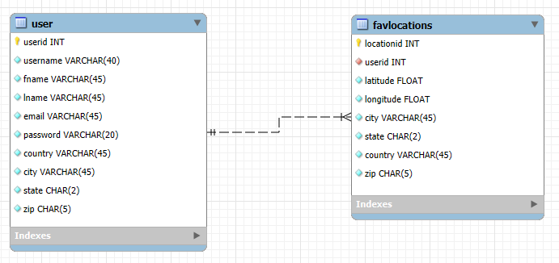

3.2. Data Dictionary
Table/Class | Attribute Name | Data Type | Description
user | userid | INT | userid is the auto-increment primary key that uniquely identifies each user
user | username | VARCHAR | Username of the user
user | fname | VARCHAR | First name of the user
user | lname | VARCHAR | Last name of the user
user | email | VARCHAR | Email of the user
user | password | VARCHAR | Password of the user
user | country | VARCHAR | Country of the user
user | city | VARCHAR | City of the user
user | state | CHAR | State of the user
user | zip | CHAR | Zip code of the user
favlocations | locationid | INT | locationid is the auto-increment primary key that uniquely identifies each favorite location
favlocations | userid | INT | userid is the foreign key that relates each favorite location to a user
favlocations | latitude | FLOAT | Latitude of the favorite location
favlocations | longitude | FLOAT | Longitude of the favorite location
favlocations | city | VARCHAR | City of the favorite location
favlocations | state | CHAR | State of the favorite location
favlocations | country | VARCHAR | Country of the favorite location
favlocations | zip | CHAR | Zip code of the favorite location

3.3. API Data
API | Data Item | Description
Google Maps | center | Current Google Maps center coordinates, returned as a dictionary including latitude and longitude
Google Maps | zoom | Current Google Maps zoom level
Google Maps | bounds | Current Google Maps bounds
Google Maps | map_type | Current Google Maps displayed map type
Google Maps | event_data | Data interactions resulting from user interactions
Open Weather Map | center | Current Open Weather Map center coordinates, returned as a dictionary including latitude and longitude
Open Weather Map | zoom | Current Open Weather Map zoom level
Open Weather Map | bounds | Current Open Weather Map bounds
Open Weather Map | map_type | Current Open Weather Map displayed map type
Open Weather Map | event_data | Data interactions resulting from user interactions
Open Weather Map | opacity | A number (0.0 – 1.0) that controls current Open Weather Map transparency
Open Weather Map | name | Optional display name for current Open Weather Map layer
Open-Meteo | latitude | Latitude of the current location that was fetched for weather data
Open-Meteo | longitude | Longitude of the current location that was fetched for weather data
Open-Meteo | hourly | Hourly weather data, returned as a string-list key value pair dictionary
Open-Meteo | hourly_units | Hourly weather data units, returned as a string-string key value pair dictionary
Google Maps Geocoding | location | Current latitude and longitude of the searched location

4. User Interface Navigation Flow

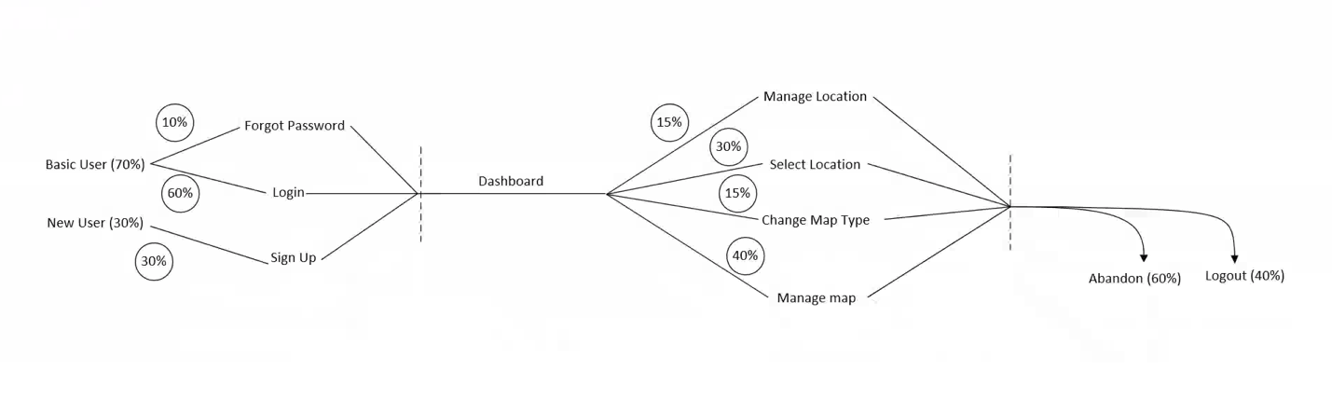

5. Requirements Traceability Matrix
Use Case Name | Requirement ID | Component name
Log In | UC-1-F-1 | User
Log In | UC-1-F-2 | User
Log In | UC-1-F-3 | User
Log In | UC-1-F-4 | Controller
Log In | UC-1-F-5 | User Model
Log In | UC-1-F-6 | Controller
Log In | UC-1-F-7 | User
Log In | UC-1-F-8 | User
Log In | UC-1-F-9 | Controller
Log In | UC-1-F-10 | User Model
Log In | UC-1-F-11 | User Model
Log In | UC-1-NF-1 | User
Display Weather Map | UC-2-F-1 | Controller
Display Weather Map | UC-2-F-2 | Controller
Display Weather Map | UC-2-F-3 | Controller
Display Weather Map | UC-2-F-4 | Controller
Display Weather Map | UC-2-F-5 | Dashboard
Display Weather Map | UC-2-F-6 | Dashboard
Display Weather Map | UC-2-F-7 | Dashboard
Display Weather Map | UC-2-F-8 | Dashboard
Display Weather Map | UC-2-NF-1 | Dashboard
Display Weather Map | UC-2-NF-2 | Controller
Select Location | UC-3-F-1 | Favorite Locations Model
Select Location | UC-3-F-2 | Controller
Select Location | UC-3-F-3 | Locations
Select Location | UC-3-F-4 | Controller
Select Location | UC-3-F-5 | Locations
Display Weekly Weather Data | UC-4-F-1 | Controller
Display Weekly Weather Data | UC-4-F-2 | Controller
Display Weekly Weather Data | UC-4-F-3 | Controller
Display Weekly Weather Data | UC-4-F-4 | Controller
Display Weekly Weather Data | UC-4-F-5 | Dashboard
Search Location | UC-5-F-1 | Locations
Search Location | UC-5-F-2 | Controller
Search Location | UC-5-F-3 | Controller
Search Location | UC-5-F-4 | Locations
Search Location | UC-5-F-5 | Locations
Search Location | UC-5-F-6 | Locations
Search Location | UC-5-F-7 | Locations
Search Location | UC-5-F-8 | Locations
Search Location | UC-5-F-9 | Locations
Search Location | UC-5-NF-1 | Controller
Manage Locations | UC-6-F-1 | Favorite Locations Model
Manage Locations | UC-6-F-2 | Favorite Locations Model
Manage Locations | UC-6-F-3 | Favorite Locations Model
Manage Locations | UC-6-NF-1 | Locations
Manage Locations | UC-6-NF-2 | Favorite Locations Model
Manage Locations | UC-6-NF-3 | Controller
Forgot Password | UC-7-F-1 | Controller
Forgot Password | UC-7-F-2 | User
Forgot Password | UC-7-F-3 | User
Forgot Password | UC-7-F-4 | User
Forgot Password | UC-7-F-5 | User Model
Forgot Password | UC-7-F-6 | User
Forgot Password | UC-7-F-7 | User Model
Forgot Password | UC-7-F-8 | Controller
Forgot Password | UC-7-F-9 | User Model
Forgot Password | UC-7-NF-1 | Controller
Sign Up | UC-8-F-1 | User
Sign Up | UC-8-F-2 | User
Sign Up | UC-8-F-3 | User
Sign Up | UC-8-F-4 | Controller
Sign Up | UC-8-F-5 | User Model
Sign Up | UC-8-F-6 | User Model
Sign Up | UC-8-F-7 | User Model
Sign Up | UC-8-F-8 | Controller
Sign Up | UC-8-NF-1 | Controller

6. Updated Requirements With Text

6.1 Log In

6.1.1 Functional

Identifier | Description
UC-1-F-1 | The user’s username must be between 5 and 40 characters long and are able to contain special characters
UC-1-F-2 | The user’s password must be between 5 and 20 characters long and contain at least one special character, capitol letter, and number
UC-1-F-3 | The password eye button must toggle the password between hidden and un-hidden
UC-1-F-4 | Upon unsuccessful login, an appropriate error message will be displayed
UC-1-F-5 | Usernames must be unique
UC-1-F-6 | The system must not allow users to continue to the dashboard if their account has not been authorized
UC-1-F-7 | Clicking the Forgot Password button must redirect the user to the forgot password screen
UC-1-F-8 | Clicking the Sign-Up button must redirect the user to the sign-up screen
UC-1-F-9 | The system must hash all passwords in a secure manner
UC-1-F-10 | After the password has been successfully hashed, the system must store in a secure manner
UC-1-F-11 | All Log In data should be stored in the system

6.1.2. Non-Functional
Identifier | Description
UC-1-NF-1 | The Log In page must be designed so users can log into their account within 2 minutes without assistance to improve overall ease of use

6.2 Display Weather Map

6.2.1. Functional

Identifier | Description
UC-2-F-1 | The Weather Map must be able to display a geographical map of the current/selected location
UC-2-F-2 | The Weather Map must be able to display a precipitation map of the current/selected location
UC-2-F-3 | The Weather Map must be able to display a wind speed map of the current/selected location
UC-2-F-4 | The Weather Map must be able to display a temperature map of the current/selected location
UC-2-F-5 | The user must be able to zoom in on all the map styles
UC-2-F-6 | The user must be able to zoom out on all the map styles
UC-2-F-7 | The user must be able to move around on all the map styles
UC-2-F-8 | The user must only be able to view one map at a time

6.2.2. Non-Functional

Identifier | Description
UC-2-NF-1 | The size of the weather map must cover the user’s entire window
UC-2-NF-2 | The system must be able to render and display all map styles within 2 seconds

6.3 Select Location

6.3.1. Functional

Identifier | Description
UC-3-F-1 | Weather App must display all the users’ favorite locations in the favorite locations section on the dashboard
UC-3-F-2 | The overall weather application must be updated according to the most recently clicked favorite location
UC-3-F-3 | The user’s current location must be at the top of the favorited location list
UC-3-F-4 | Each favorite location must show their appropriate city and abbreviated state in the following format: <Ellensburg, WA>
UC-3-F-5 | The user must only select one location from their favorite locations list at a time

6.4 Display Weekly Weather Data

6.4.1. Functional

Identifier | Description
UC-4-F-1 | Upon successful login, the system shall retrieve weather data for the user's current location from a weather data provider within 2 seconds
UC-4-F-2 | The system must update weather data when the user has refreshed the page
UC-4-F-3 | The system must update weather data when the user selects a different favorite location
UC-4-F-4 | The Weather App must display icons that represent the status of weather for all days
UC-4-F-5 | The weekly weather data must display the correct day, icon, and temperature in the following format: <Mon, Icon, 55°F>

6.5 Search Location

6.5.1. Functional

Identifier | Description
UC-5-F-1 | Users must be able to search for new locations using the search bar on the Weather Map
UC-5-F-2 | If the user’s searched location cannot be found, the system must display an appropriate error message
UC-5-F-3 | The system only allows users to search for new locations using an address, city, state, country, or generic place name
UC-5-F-4 | The search bar must be located at the top-right corner of the Weather Map
UC-5-F-5 | If the user provides a valid address, the system must zoom to the address
UC-5-F-6 | If the user provides a valid city, the system must zoom to the city
UC-5-F-7 | If the user provides a valid state, the system must zoom to the state
UC-5-F-8 | If the user provides a country, the system must zoom to the country
UC-5-F-9 | If the user provides a generic place name, the system must zoom to the generic place name

6.5.2. Non-Functional

Identifier | Description
UC-5-NF-1 | Upon successful search, the Weather Map must zoom to the user’s searched location within 2 seconds

6.6 Manage Locations

6.6.1. Functional

Identifier | Description
UC-6-F-1 | Users must be able to successfully add a new favorite location using the Manage Locations interface
UC-6-F-2 | Users must be able to successfully remove any location they have added or favorited using the Manage Locations interface
UC-6-F-3 | Users must be able to edit any favorite location using the Manage Locations interface

6.6.2. Non-Functional

Identifier | Description
UC-6-NF-1 | The user’s current location must be at the top of the favorited location list
UC-6-NF-2 | The system must securely store the user’s favorited location data
UC-6-NF-3 | The system must display all user’s locations within two 2 seconds of loading the Manage Locations interface

6.7 Forgot Password

6.7.1. Functional

Identifier | Description
UC-7-F-1 | Upon unsuccessful password update, the system must display a failure message
UC-7-F-2 | The user’s updated password and confirmed password must be between 5 and 20 characters long and contain at least one special character, capital letter, and number
UC-7-F-3 | The password eye button must toggle the updated password between hidden and un-hidden
UC-7-F-4 | The password eye button must toggle the confirmed password between hidden and un-hidden
UC-7-F-5 | The updated password must match the confirmed password
UC-7-F-6 | The updated password must not be the exact same as the pre-existing password
UC-7-F-7 | The system must display an appropriate error message if the user’s password and confirmed password are not matching
UC-7-F-8 | The system must hash user’s updated password in a secure manner
UC-7-F-9 | After the user’s updated password is successfully hashed, the system must store in a secure manner

6.7.2. Non-Functional

Identifier | Description
UC-7-NF-1 | The loading time for resetting a forgotten password must take less than 2 seconds to complete

6.8 Sign Up

6.8.1. Functional

Identifier | Description
UC-8-F-1 | The user’s username must be between 5 and 40 characters long and be able to contain special characters
UC-8-F-2 | The user’s password must be between 5 and 20 characters long and contain at least one special character, capitol letter, and number
UC-8-F-3 | The password eye button must toggle the password and confirm password between hidden and un-hidden
UC-8-F-4 | Upon unsuccessful sign up, an appropriate error message will be displayed
UC-8-F-5 | Usernames must be unique
UC-8-F-6 | The system must hash all password in a secure manner
UC-8-F-7 | After the password is successfully hashed, the system must store in a secure manner
UC-8-F-8 | The system must store all user credentials and location information in a secure manner

6.8.2. Non-Functional

Identifier | Description
UC-8-NF-1 | The Sign Up page must be designed so users can create an account within 2 minutes without assistant to improve overall ease of use

